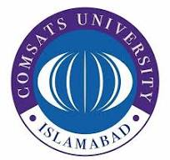

Lahore Campus
Web development
Project till Mids

Submitted to: Sir Usman Akram
Submitted by: Abdullah Saleem
Roll no: FA24-BCS-141
Section: B
Date: Oct 28 ,2026

Submitted to: Mr. Abdul-Karim
Submitted by: Abdullah Saleem
Roll no: FA24-BCS-141
Section: B
Date: 7 Nov,2024

Hero:
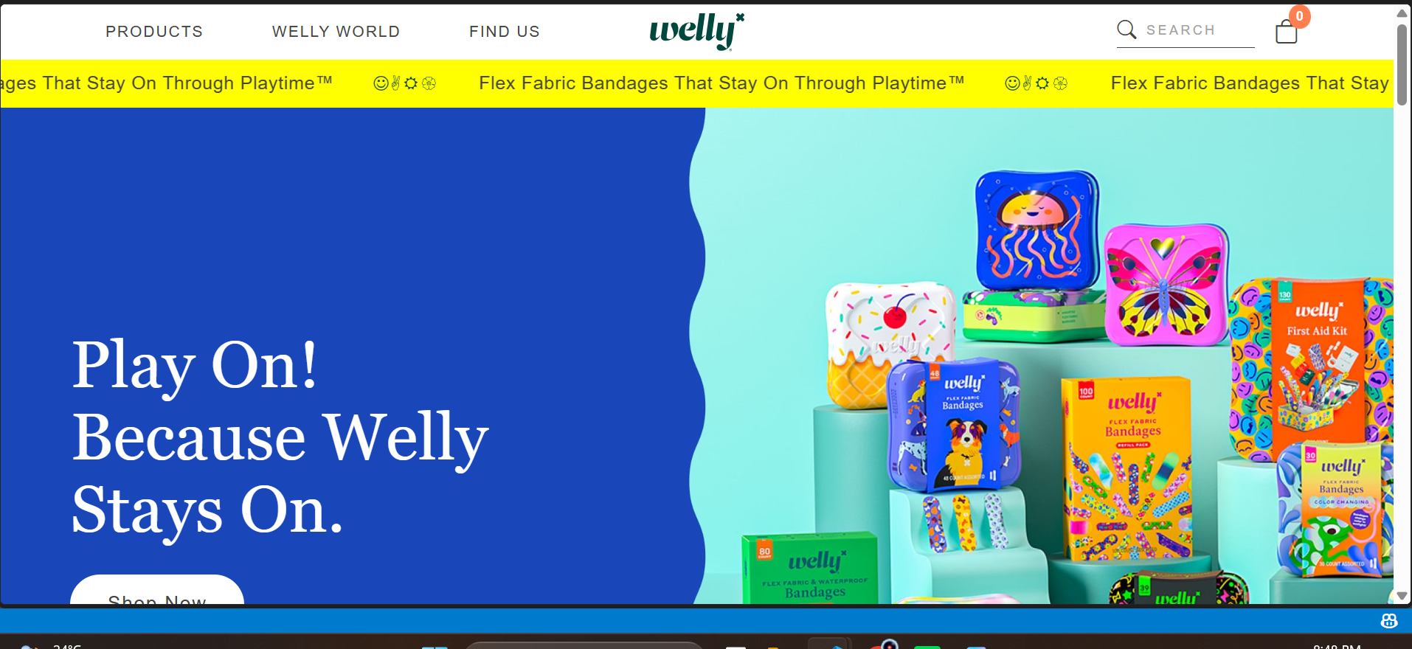

Products:
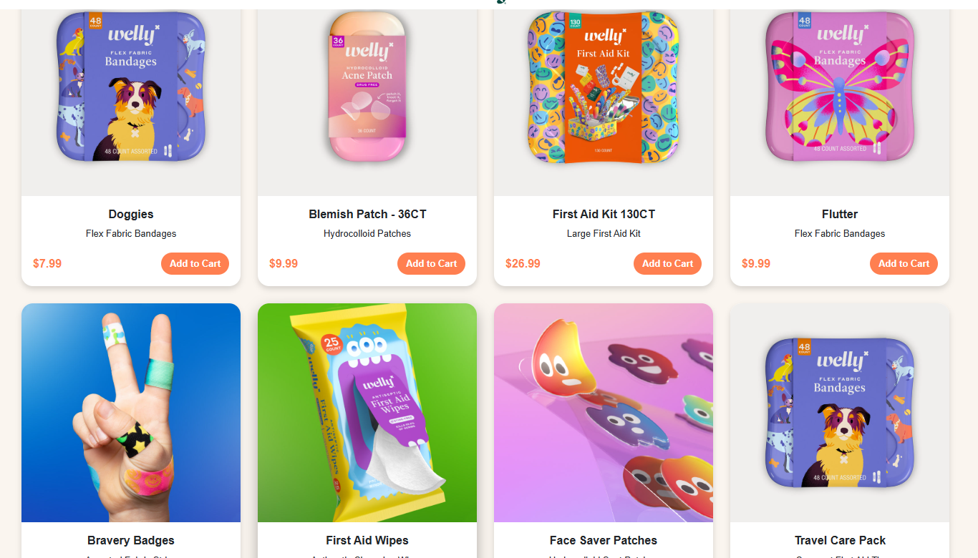

Product.html
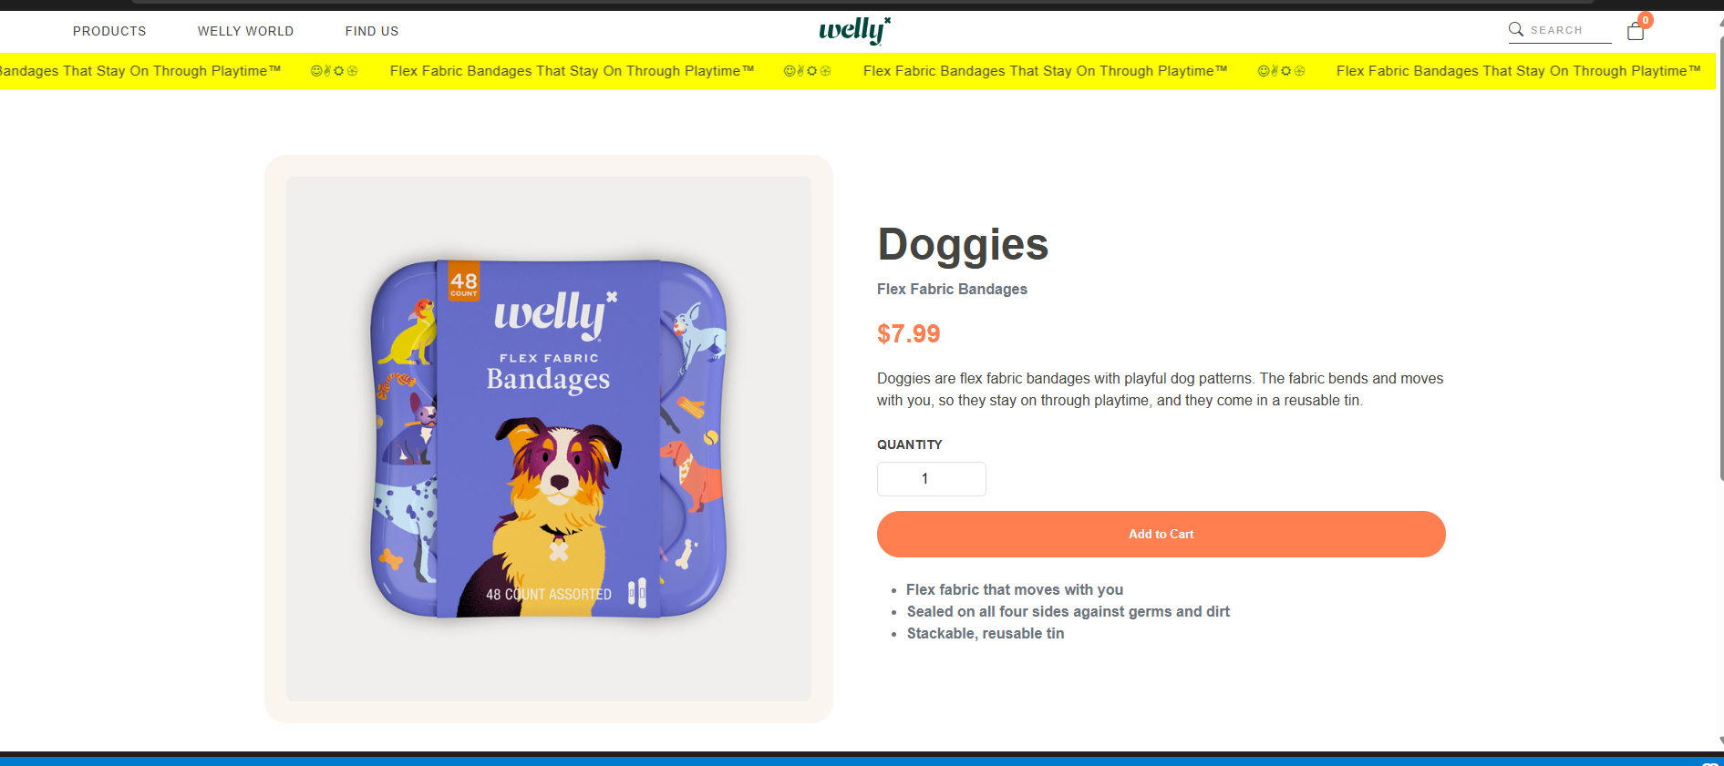
Footer:
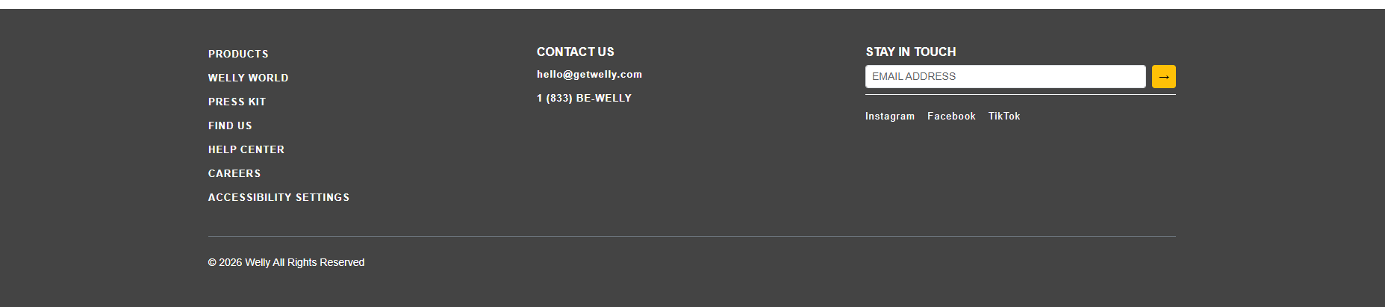

Reviews:


